《国际商务谈判（双语）》课程教学大纲
一、课程基本信息
英文名称 | International Business Negotiation(Bilingual Course) | 课程代码 | IETT2012
课程性质 | 专业选修课程 | 授课对象 | 国际贸易专业学生
学 分 | 3 | 学 时 | 54
主讲教师 | 李晶 | 修订日期 | 2023.8
指定教材 | Roy J. Lewicki, Bruce Barry, David M. Saunders. Business Negotiation(8th edition)[M]. CHINA RENMIN UNIVERSITY PRESS, 2020.
二、课程目标
（一）总体目标：
本课程是国际经济与贸易专业的主要选修课程之一。本课程主要包括跨文化谈判、谈判前策划、价格谈判等主要内容。本课程突出企业在谈判领域的社会责任和可持续发展，通过课堂讲授和案例教学，本课程将培养有道德的谈判者。
本课程用中文和英文向学生介绍国际商务环境下的商务谈判概况，学生应掌握商务沟通和谈判的基本原理、理论、方法以及谈判艺术，然后运用这些原理、理论、方法和技巧，结合具体案例有针对性地分析和解决问题，真正做到理论与实践相结合，理论指导实践，实践检验。理论。使学员对商务谈判活动从自发阶段到自觉阶段的认识，从被动应付到理性操作的转变，并在当前和今后的实际谈判活动中灵活运用。
（二）课程目标：
（课程目标规定某一阶段的学生通过课程学习以后，在发展德智体美劳等方面期望实现的程度，它是确定课程内容、教学目标和教学方法的基础。）（五号宋体）
课程目标1： 通过学习商务沟通与谈判的基本原理和相关知识，熟悉并能创造性地运用沟通与谈判的策略和技巧。
1．1 理解商务沟通和商务谈判的基本原理
1．2 熟悉商务沟通和商务谈判的基本流程
1．3 掌握商务沟通和商务谈判的策略技巧
课程目标2：通过学习了解国际商务谈判的过程，掌握国际谈判的策略和技巧
2．1 了解国际商务谈判的过程
2．2 掌握国际谈判的策略和技巧
课程目标3：学习掌握如何有效、系统地计划和准备一个商务谈判，包括撰写商务谈判计划书，掌握实际商务谈判的过程。
3．1 掌握商务谈判计划书撰写技巧
3．2掌握实际商务谈判过程
（三）课程目标与毕业要求、课程内容的对应关系（小四号黑体）
表1：课程目标与课程内容、毕业要求的对应关系表 （五号宋体）
课程目标 | 课程子目标 | 对应课程内容 | 对应毕业要求
课程目标1 | 1.1 | 商务沟通和商务谈判基本原理 | 掌握商务沟通、谈判的定性、定量分析方法，掌握商务沟通和谈判的基本流程和策略技巧，具有一定商务沟通和商务谈判能力。
课程目标1 | 1.2 | 商务沟通和商务谈判基本流程 | 掌握商务沟通、谈判的定性、定量分析方法，掌握商务沟通和谈判的基本流程和策略技巧，具有一定商务沟通和商务谈判能力。
课程目标1 | 1.3 | 商务沟通和商务谈判策略技巧 | 掌握商务沟通、谈判的定性、定量分析方法，掌握商务沟通和谈判的基本流程和策略技巧，具有一定商务沟通和商务谈判能力。
课程目标2 | 2.1 | 商务谈判计划书撰写技巧 | 培养良好的思想品德、社会公德和遵守商业伦理和道德规范；掌握商务谈判计划书撰写技巧和提升实际商务谈判能力。
课程目标2 | 2.2 | 模拟商务谈判 | 培养良好的思想品德、社会公德和为人民服务的职业道德；掌握商务谈判计划书撰写技巧和提升实际商务谈判能力。
课程目标3 | 3.1 | 商务谈判中的礼仪和礼节 | 理解商务沟通、谈判中的礼仪和礼节，了解文化差异，通过沟通塑造自我形象并建立良好人际关系。
课程目标3 | 3.2 | 了解文化差异，塑造自我形象 | 理解商务沟通、谈判中的礼仪和礼节，了解文化差异，具备国际视野，通过沟通塑造自我形象并建立良好人际关系。
三、教学内容（四号黑体）
（具体描述各章节教学目标、教学内容等。实验课程可按实验模块描述）
第一章 International Business Negotiation: An Overview(1)
1.教学目标：（1）介绍课程大体内容，激发学习兴趣；（2）了解国际商务谈判的重要价值；（3）了解商务谈判与国际商务谈判基本概念。
2.教学重难点：商务谈判与国际商务谈判基本概念
3.教学内容
一、Introduction
（一） Scope of IBN
（二）Features of IBN

二、International Business Negotiation(IBN) Architecture
The architecture of global negotiations consists of three aspects: negotiation environment, negotiation setting , and negotiation process. The negotiation environment refers to the business climate that surrounds the negotiations and is beyond the control of negotiators. The negotiation setting refers to such aspects as the relative power of the negotiators and the nature of their interdependence. The negotiating process is made up of events and interactions that take place between parties to reach an agreement.

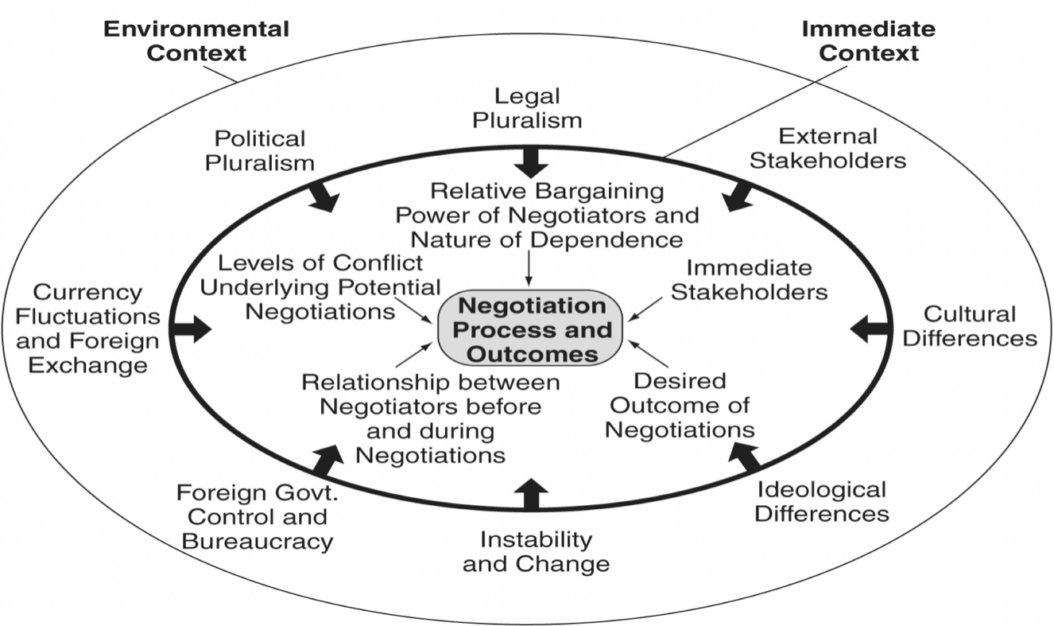
Figure 1.1 IBN Architecture

(一)Negotiation Environment
1. Legal Pluralism
2. Political Pluralism
3. Currency Fluctuation and Foreign Exchange
4. Foreign Government Controls and Bureaucracy
5.Instability and Change
6.Cultural Differences
7.Ideological Differences
8. External Stakeholders
(二)Negotiation Setting
1. Relative Bargaining power of Negotiators and Nature of Dependence
2. Levels of Conflict Underlying Potential Negotiations
3.Relationship Between Negotiators Before and During Negotiations
4. Desired Outcome of Negotiations
5. Impact of Immediate Stakeholders
6. Style of Negotiations
(三)Negotiation Process
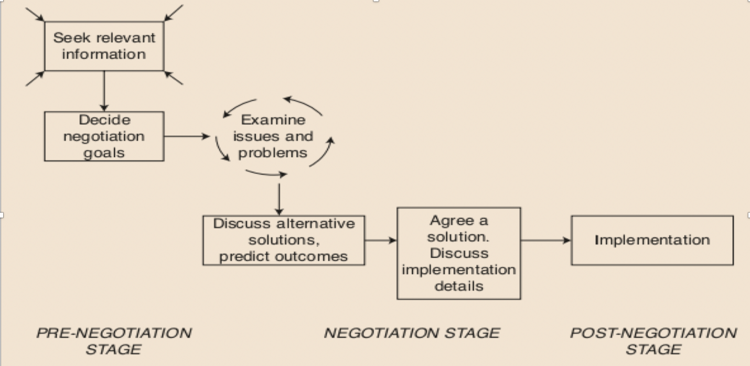
Figure 1.2 Using a systematic problem-solving approach to international business negotiation

Readings
- Required: D. Druckman Negotiation and Identity: Implications for Negotiation Theory[J] International Negotiation, 2001, 6(2)
- Required: Gunia Brian C. Ethics in Negotiation: Causes and Consequences [J] Academy of Management Perspectives,2019
4.教学方法：讲授、讨论、比较、案例分析。
5.教学评价：
（1）What are the three reasons negotiations occur?
（2）Define international business negotiation

第二章 International Business Negotiation: An Overview(2)
1.教学目标 ：了解并掌握国际商务谈判相关理论
2.教学重难点：（一）Maslow's Hierarchy of Needs；（二）Harvard Principled negotiation；（三）Game Theory；（四）Risk Decision Theory
3.教学内容：
一、Negotiation theory
（一）Maslow's Hierarchy of Needs
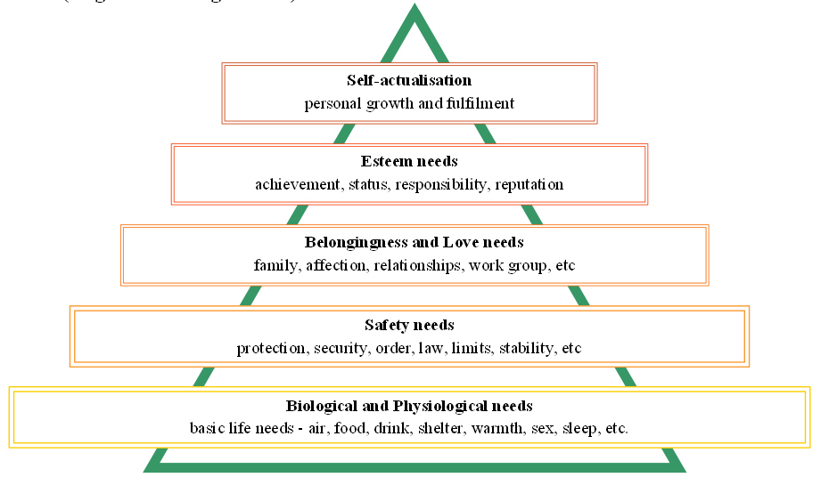
Figure 2.1 Maslow’s Hierarchy of Needs(Original five-stage model)

（二）Harvard Principled negotiation
- People: separate the people from the problem
- Interests: focus on interests not positions
- Gaining: invent options for mutual gain
- Criteria: introduce objective criteria

（三）Game Theory
Game theory is the study of mathematical models of strategic interaction between rational decision-makers. It has applications in all fields of social science, as well as in logic and computer science.
- Discrete and continuous games
- Cooperative / Non-cooperative
- Symmetric / Asymmetric
- Zero-sum / Non-zero-sum
- Simultaneous / Sequential
- Perfect information and imperfect information
- …….

表2.1 谈判困境
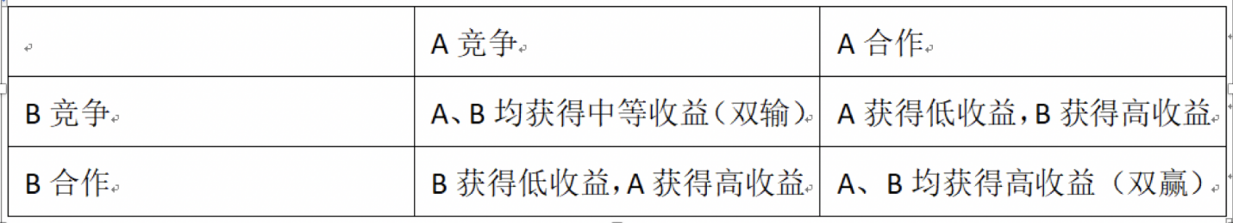

（四）Risk Decision Theory
The prospect theory
- In 2002 Daniel Kahneman shared the Nobel Prize in Economics but unfortunately Amos Tversky had died by that time and did not get his share of the fame.
- renewed the empirical study of economic behavior with less emphasis on rationality presuppositions.
- people's attitudes toward risks concerning gains may be quite different from their attitudes toward risks concerning losses.

Game: Risk-aversion Vs. Risk-seeking
risk-aversion
Choice A：get 50,000$
Choice B：50% win 100,000$，50% get nothing

risk-seeking
Choice C：loss of 50,000$
Choice D：50% no loss，50% loss of 100,000$

二、Sustainable Economic Development（SED）
Discussion
（1）What’ s the meaning of SED?
（2）Why SED?
（3）The relationship between negotiation and SED?

Readings
- Required: Gunia Brian C. Deceptive Negotiating: The Role of the Environmental Cue [J] Academy of Management Perspectives,2019
4.教学方法：讲授、讨论、比较、案例分析
5.教学评价
（1）List some environmental and setting factors in the contexts of international negotiation.
（2）Define "zero-sum" situation.

第三章 Perception, Cognition and Emotion
1.教学目标：了解如何管理谈判中的认知偏差和情绪问题
2.教学重难点：Perceptual Distortion；Cognitive Biases (Errors in Processing Information)
3.教学内容
一、Perception
（一）Definition
• The process by which individuals connect to their environment.
• A complex physical and psychological process
• A “sense-making” process
（二）The process of perception
• The process of ascribing meaning to messages and events is strongly influenced by the perceiver’s current state of mind, role, and comprehension of earlier communications.
• People interpret their environment in order to respond appropriately.
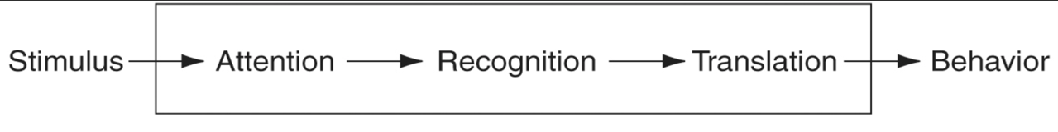
• The complexity of environments makes it impossible to process all of the information. People develop shortcuts to process information and these shortcuts create perceptual errors.
Figure 3.1 The process of perception

二、Perceptual Distortion
（一）Stereotyping
- Is a very common distortion
- Occurs when an individual assigns attributes to another solely on the basis of the other’s membership in a particular social or demographic category
（二）Halo Effect
    - Are similar to stereotypes
    - Occur when an individual generalizes about a variety of attributes based on the knowledge of one attribute of an individual
（三）Selective Perception
- Perpetuates stereotypes or halo effects
- The perceiver singles out information that supports a prior belief but filters out contrary information
（四）Projection
- Arises out of a need to protect one’s own self-concept
- People assign to others the characteristics or feelings that they possess themselves

二、Cognitive Biases (Errors in Processing Information)
Negotiators have a tendency to make systematic errors when they process information. These errors, collectively labeled cognitive biases, tend to impede negotiator performance.
Irrational escalation of commitment
- Mythical fix-pie beliefs
- Anchoring and adjustment
- Issue framing and risk
- Availability of information
- The winner’s curse
- Overconfidence
- The law of small numbers
- Self-serving biases
- Endowment effect
- Ignoring others’ cognitions
- Reactive devaluation

三、Social responsibility and professional ethics of negotiators
Discussion
- Social responsibility of negotiators
- Professional ethics of negotiators
- Case Study

Readings
- Required: Gunia Brian C.;Levine Emma E. Deception as competence: The effect of occupational stereotypes on the perception and proliferation of deception [J] Organizational Behavior and Human Decision Processes,2016
- Optional: Canidio Andrea; Karle Heiko. The focusing effect in negotiations [J]Journal of Economic Behavior & Organization. 2022,197.

4.教学方法：讲授、讨论、比较、案例分析
5.教学评价：
（1）Define perception and perception process.
（2）What is stereotyping?
（3）How are frames critical in negotiations?
（4）Explain "Irrational Escalation of Commitment."
（5）Explain “Reactive Devaluation”

第四章 Communication Skills for Effective Negotiation
1.教学目标；了解沟通的基本模型，并掌握如何在商务谈判中进行有效的沟通
2.教学重难点：Basic Models of Communication；How to improve communication in negotiation
3.教学内容
一、Basic Models of Communication
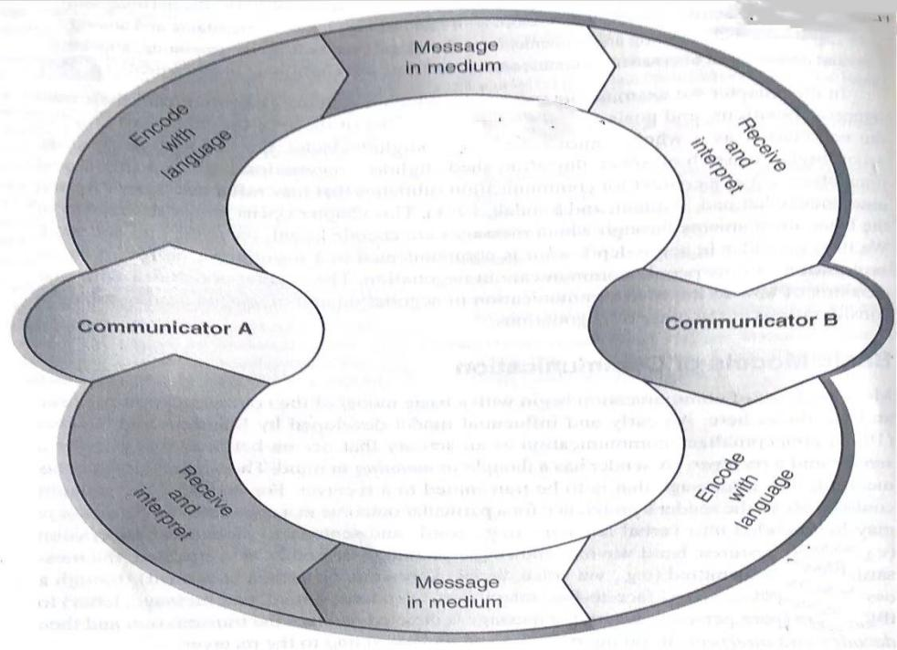
Communication processes, both verbal and nonverbal, are critical to achieving negotiation goals and to resolving conflicts. Negotiation is a process of interaction. Negotiation is a context for communication subtleties that influence processes and outcomes.
Figure 4.1 A transactional model of communication involving two parties
Source: Adapted from Foulger, D. “Models of the communication process”. February 2004, unpublished paper available at http://foulger. info/davis/research/unifiedModelOfCommunication.htm

二、How people communicate in Negotiation
（一）Use of language
  - Logical level (proposals, offers)
  - Pragmatic level (semantics, syntax, style)
（二）Use of nonverbal communication
  - Making eye contact
  - Adjusting body position
  - Nonverbally encouraging or discouraging what the other says
（三）Selection of a communication channel
  - Communication is experienced differently when it occurs through different channels
  - People negotiate through a variety of communication media – by phone, in writing and increasingly through electronic channels or virtual negotiations
  - Social bandwith distinguishes one communication channel from another.（the ability of a channel to carry and convey subtle social cues from sender to receiver）

三、How to improve communication in negotiation
（一）Use of questions: two basic categories
1.Manageable questions
    - cause attention or prepare the other person’s thinking for further questions:
      - “May I ask you a question?”
    - getting information
      - “How much will this cost?”
    - generating thoughts
      - “Do you have any suggestions for improving this?”
2. Unmanageable questions
    - cause difficulty
      - “Where did you get that dumb idea?”
    - give information
      - “Didn’t you know we couldn’t afford this?”
    - bring the discussion to a false conclusion
      - “Don’t you think we have talked about this enough?”
（二）Listening: three major forms
  - Passive listening: Receiving the message while providing no feedback to the sender
  - Acknowledgment: Receivers nod their heads, maintain eye contact, or interject responses
  - Active listening: Receivers restate or paraphrase the sender’s message in their own language
（三）Role reversal
  - Negotiators understand the other party’s positions by actively arguing these positions until the other party is convinced that he or she is understood
  - Impact and success of the role-reversal technique
（1）Effective in producing cognitive changes and attitude changes
（2）When the positions are compatible, likely to produce acceptable results; when the positions are incompatible, may inhibit positive change
（3）Not necessarily effective overall as a means of inducing agreement between parties

Readings
- Required: Gunia Brian C.;Lewicki Roy J. Bartering as a Blind Spot: A Call to Action from COVID‐19 [J] Negotiation Journal,2020

4.教学方法：讲授、讨论、比较、案例分析
5.教学评价：
（1）Describe the communication model.
（2）What three main techniques are available for improving communication in negotiation?

第五章 International and Cross-Cultural Negotiation(1)
1.教学目标：理解国际商务谈判与国内商务谈判的差异
2.教学重难点：国际商务谈判的复杂性
3.教学内容：
一、International Negotiation: Art and Science
International negotiations are much more complex than domestic negotiations. They challenge the negotiators to understand the science of negotiation while developing their artistry.
- The science of negotiation provides research evidence to support broad trends that often, but not always, occur during negotiation.
- The art of negotiation is deciding which strategy to apply when, and choosing which models and perspectives to apply to increase cross-cultural understanding.

二、What Makes International Negotiations Different?
Two overall contexts have an influence on international negotiations:
（一）Environmental context
  - Includes environmental forces that neither negotiator controls that influence the negotiation
- Political and legal pluralism
- International economics
- Foreign governments and bureaucracies
- Instability
- Ideology
- Culture
- External stakeholders
（二）Immediate context
  - Includes factors over which negotiators appear to have some control
- Relative bargaining power
- Levels of conflict
- Relationship between negotiators
- Desired outcomes
- Immediate stakeholders

Readings
- Required: Brett Jeanne M.;Gunia Brian C.;Teucher Brosh M. Culture and Negotiation Strategy: A Framework for Future Research [J] Academy of Management Perspectives,2017

4.教学方法：讲授、讨论、比较、案例分析
5.教学评价：
（1）According to Salacuse, what are the six factors that make global negotiations more challenging than domestic negotiations?
（2）Foster suggests that culture can influence negotiations across borders in what different ways?
（3）What are the five dimensions in Hofstede’s cultural framework?

第六章 International and Cross-Cultural Negotiation(2)
1.教学目标：理解文化对国际商务谈判中的影响；掌握分析国家文化的模型
2.教学重难点：分析国家文化的模型
3.教学内容
一、Understanding Culture
- Culture as learned behavior
  - A catalogue of behaviors the foreign negotiator should expect
- Culture as shared values

二、The Influence of Culture on Negotiation
（一）Impact of culture on negotiation
- Case study
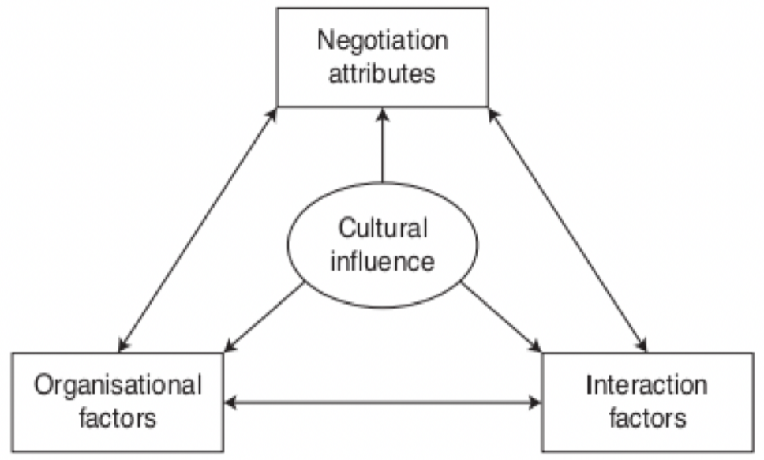
Figure 6.1 Impact of culture on negotiation
Note: In a particular international business negotiation, much of what is explained in terms of culture is probably a combination of culture, interaction, organization factors and negotiator attributes/personality.

（二）Ten ways that culture can influence negotiation
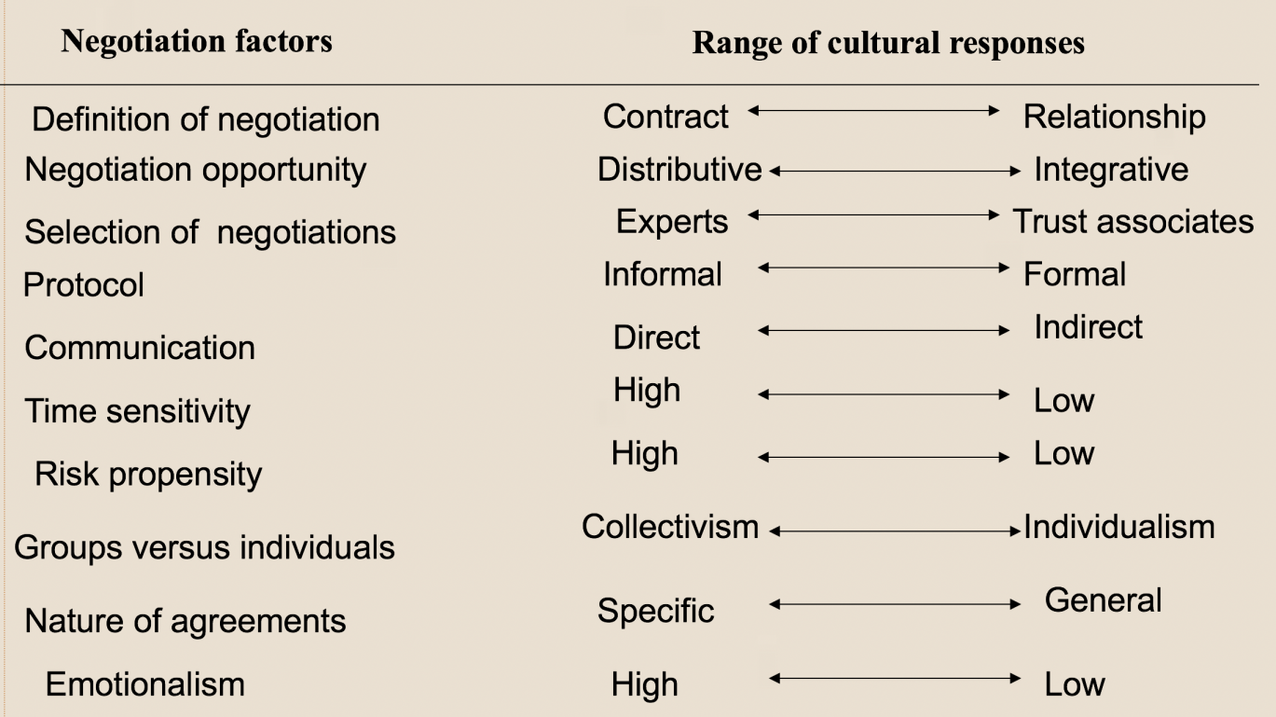
Table 6.1 ten ways that culture can influence negotiation

三、Deeper Cultural Characteristics
（一）Hall’s Framework
  - Relationship
  - Communication
  - Time
  - Space
（二）Hofstede’s Cultural Dimensions
  - Power Distance （Distribution of Power）
  - Uncertainty Avoidance (Tolerance for Uncertainty)
  - Individualism Versus Collectivism
  - Masculinity (Harmony Versus Assertiveness)

四、Traits for Coping with Culture
  - Negotiation Goals: Contract or Relationship
  - Negotiating Attitude
  - Personal Style: Informal or Formal
  - Communication: Direct or Indirect
  - Sensitivity to Time: High or Low
  - Emotions: High or Low
  - Form of Agreement: General or Specific
  - Building on Agreement: Bottom Up or Top Down
  - Team Organization: One Leader Versus Consensus
  - Risk Taking: High or Low

五、Gender discrimination in cross-cultural negotiations
- Case Study & Video
- Discussion

Readings
- Required: Daisung Jang, Hyeran Choi, Jeffrey Loewenstein. Integration Through Redefinition: Revisiting the Role of Negotiators’ Goals[J] Group Decision and Negotiation, 2021, 30(5)
- Required: Ziyue Wan; Hao Yao; Shili Sun; Xin Gao. Cross-cultural Negotiation: Understanding Is the Key to Success [J]International Journal of Social Science and Education Research. 2022, 5(3).
4.教学方法：讲授、讨论、比较、案例分析
5.教学评价：
- The Gender discrimination in global negotiation （case study）
第七章 Effective Conflict Management
1.教学目标：理解冲突概念以及不同水平的冲突、理解冲突的作用、掌握冲突管理的策略
2.教学重难点：冲突管理策略
3.教学内容
一、The definition of conflict
- Conflict may be defined as a:
"sharp disagreement or opposition" and includes "the perceived divergence of interest, or a belief that the parties' current aspirations cannot be achieved simultaneously"
- Inherent in and is part of any negotiated business deal.
- Negotiation is a process by which people with conflicting interests determine how they are going to allocate resources or work together

二、Levels of conflict
（一）Intrapersonal or intrapsychic conflict
  - Conflict that occurs within an individual
    - We want an ice cream cone badly, but we know that ice cream is very fattening
（二）Interpersonal conflict
  - Conflict is between individuals
    - Conflict between bosses and subordinates, spouses, siblings, roommates, etc.
（三）Intragroup Conflict
  - Conflict is within a group
    - Among team and committee members, within families, classes etc.
（四）Intergroup Conflict
  - Conflict can occur between organizations, warring nations, feuding families, or within splintered, fragmented communities
  - These negotiations are the most complex

三、Functions and dysfunctions of conflict
- Competitive, win-lose goals
- Misperception and bias
- Emotionality
- Decreased communication
- Blurred issues
- Rigid commitments
- Magnified differences, minimized similarities
- Escalation of conflict

四、Styles of Conflict Management
1. Contending
Actors pursue own outcomes strongly, show little concern for other party obtaining their desired outcomes
2. Yielding
Actors show little interest in whether they attain own outcomes, but are quite interested in whether the other party attains their outcomes
3. Inaction
Actors show little interest in whether they attain own outcomes, and little concern about whether the other party obtains their outcomes
4. Problem solving
Actors show high concern in obtaining own outcomes, as well as high concern for the other party obtaining their outcomes
5. Compromising
Actors show moderate concern in obtaining own outcomes, as well as moderate concern for the other party obtaining their outcomes
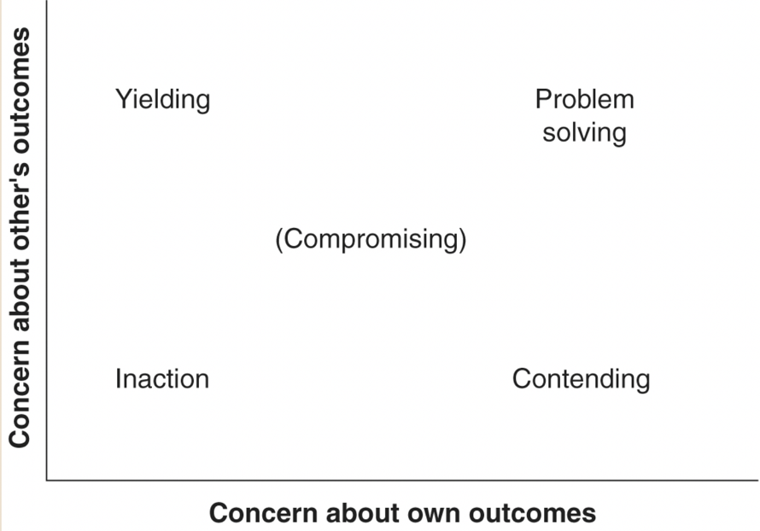
Figure 7.1 The dual concerns mode
五、Ethical issues in conflict management
• What are the ethical issues in conflict management?
• Case Study
• Discussion

Readings
- Required: Jimena Ramirez Marin; Mara Olekalns; Wendi Adair. Normatively Speaking: Do Cultural Norms Influence Negotiation, Conflict Management, and Communication? [J]Negotiation and Conflict Management Research. 2019. 12(2).
- Optional: What Makes Some Intercultural Negotiations More Difficult Than Others? Power Distance and Culture-Role Combinations[J]. Meina Liu;Lin Zhu;Ioana A. Cionea. Communication Research. 2019(4).
4.教学方法：讲授、讨论、比较、案例分析
5.教学评价：
- The Dual Concerns Model is a two-dimensional framework that postulates that people in conflict have two independent types of concern. What are those two types of concerns?
- Name the four levels of conflict that are commonly identified.
- What are the five major strategies for conflict management (as identified in the Dual Concerns framework)?

第八章 Distributive Bargaining and Integrative Negotiation
1.教学目标：理解Distributive Bargaining and Integrative Negotiation差异
2.教学重难点：Distributive Bargaining and Integrative Negotiation差异
3.教学内容
一、Distributive Bargaining
（一）The distributive Bargaining situation
- Goals of one party are in fundamental, direct conflict to another party
- Resources are fixed and limited
- Maximizing one’s own share of resources is the goal for both parties
（二）The role of alternatives to a negotiated agreement
- Alternatives give the negotiator power to walk away from the negotiation
– If alternatives are attractive, negotiators can:
- Set their goals higher
- Make fewer concessions
– If there are no attractive alternatives:
• Negotiators have much less bargaining power
二、Integrative Negotiation
（一）What Makes Integrative Negotiation Different
- Focus on commonalties rather than differences
- Address needs and interests, not positions
- Commit to meeting the needs of all involved parties
- Exchange information and ideas
- Invent options for mutual gain
- Use objective criteria to set standards
（二）Key steps in the integrative negotiation process
- Identify and define the problem
- Understand the problem fully
– identify interests and needs on both sides
- Generate alternative solutions
Evaluate and select among alternatives
三、Factors That Facilitate Successful Integrative Negotiation
- Some common objective or goal
- Faith in one’s own problem-solving ability
- A belief in the validity of one’s own position and the other’s perspective
- The motivation and commitment to work together
- Trust
- Clear and accurate communication
- An understanding of the dynamics of integrative negotiation
四、Why Integrative Negotiation is Difficult to Achieve
- The history of the relationship between the parties
– If contentious in past, it is difficult not to look at negotiations as win-lose
- The belief that an issue can only be resolved distributively
– Negotiators are biased to avoid behaviors necessary for integrative negotiation
- The mixed-motive nature of most negotiating situations
– Purely integrative or purely distributive situations are rare
- The conflict over the distributive issues tends to drive out cooperation, trust needed for finding integrative solutions
五、Trust in Integrative Negotiation
- What is the trust?
- Do you think trust is important in negotiation?
- How to build trust in negotiation?
4.教学方法：讲授、讨论、比较、案例分析
5.教学评价：
- Strategies for small enterprises negotiating with large firms（case study）

第九章 Prenegotiation Planning(1)
1.教学目标：了解Selecting Negotiators；Knowing one’s position；Knowing the negotiations limits。
2.教学重难点：Knowing one’s position；Knowing the negotiations limits。
3.教学内容
一、Selecting Negotiators
（一）Attributes of a successful negotiator
1.Flexibility:
establishes as soon as possible the goals of negotiation and knows the general shape of the kind of agreement that he or she wishes to reach but remains flexible about the various possible ways of attaining these goals.
2.Interpersonal Sensitivity:
sensitive to various cues about the other negotiator while not being too reactive to what one sees.
3.Inventiveness:
continually strives to be creative, to evaluate the underlying interests of the two sides, and on that basis to develop as many ways as possible to satisfy these interests.
4.Patience:
looking beyond the possibility of immediate gain, even if this means accepting less than one would like in the short term, while negotiating in ways that make sense in the long run.
5.Tenacity:
willing to persist in efforts to turn each other around, to transform a potentially adversarial relationship into a more collaborative arrangement.
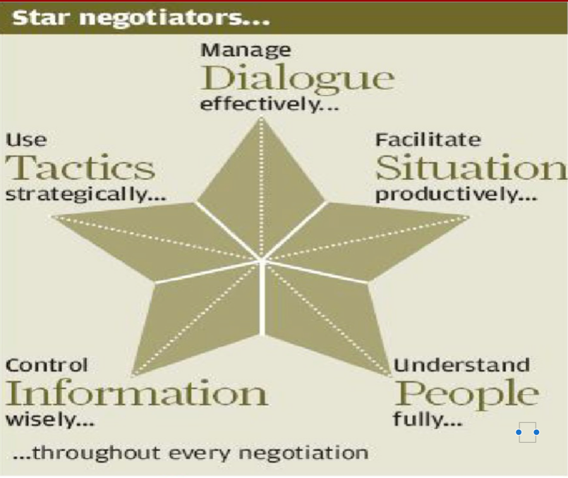
Figure 9.1 Star negotiators

（二）Negotiator training methods
- A wide range of training methods is used to develop the skills needed by international business negotiators, including
  - negotiation simulations
  - behavior modelling
  - role plays
  - case studies
- Many negotiator training programmes consist of one- to three-day courses and focus on building practical negotiation skills
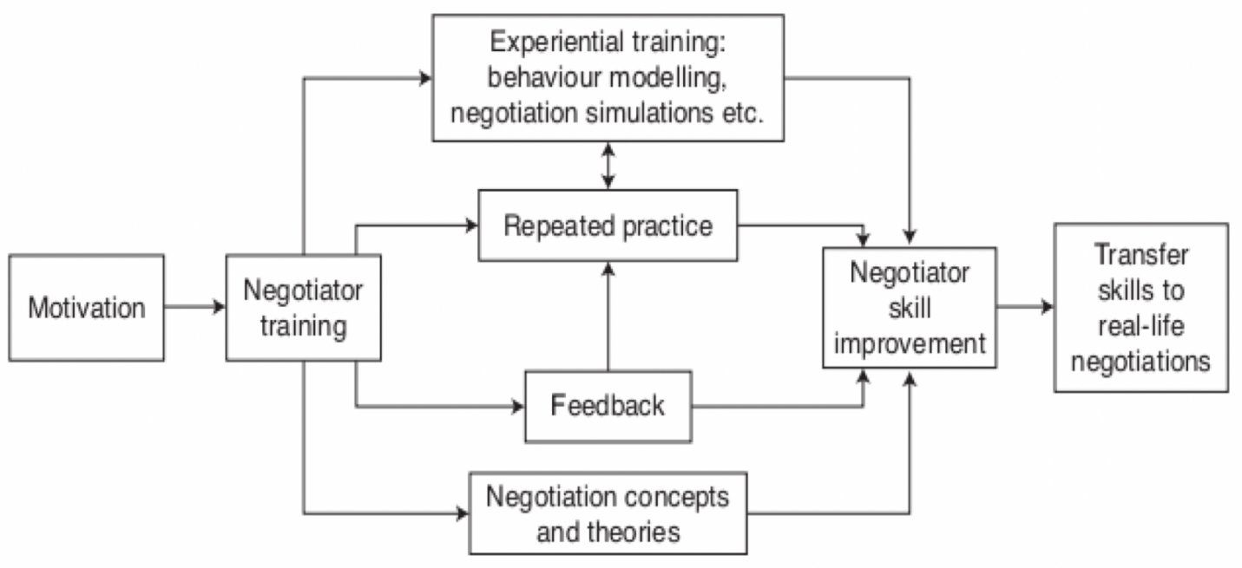

Figure 9.2 Developing negotiation skills
Note: The effectiveness of a particular training programme in building negotiating skills depends both on training content and the training methods used.\

二、Knowing one’s position
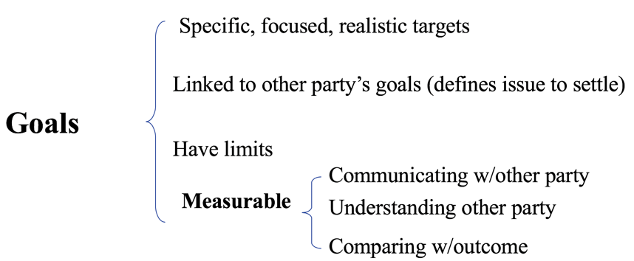
（一）Goals


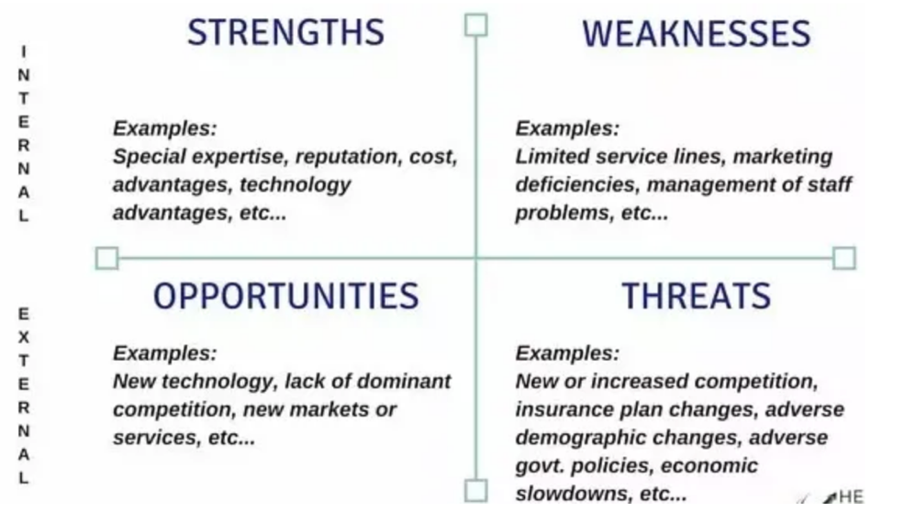
（二）Strengths and Weaknesses
Figure 9.3 SWOT Analysis

三、Knowing the negotiations limits
（一）Target and Reservation Points
（二）BATNA
BATNA=the best alternatives to a negotiated agreement. It is a standard against which a proposed agreement should be evaluated.

（三）Determining Reservation Point
Reservation Point=which a negotiator is indifferent between reaching a settlement and walking away from negotiation.

（四）Bargaining Zone

（五）Power
- Power is a social phenomenon, endowing people with control over other people, events, or activities. Power requires a relationship and interaction.
- Negotiating power is the ability that one negotiator can make use of to control over and affect the other side’s decision making and to resolve the dispute and attain the target of negotiation.

Case study:
- Brainstorm alternatives
the negotiators should brainstorm to generate alternatives if the overseas distributor refuse to accept 6% commission on sales.
Alternative1: Distributing through a home-based company.
Alternative 2: Distributing on the internet.
Alternative3: Increasing the foreign distributors’ commission to 10%
- Evaluate each alternative
Assume the sales potential in the market is $20 million. The probability of reaching that level under the three alternatives is 0.5,0.2 and 0.3 respectively. The commission and sales expenses vary as following:A1 7%, A2 4%, A3 10%.
Thus the expected value of sales is as followings:
Al: $20 million*0.5=$10 million
A2: $20 million*0.2=$4 million
A3: $20 million*0.3=$6 million
Sales commission under the three alternatives will be as followings:
Al: 7%*$10 million=$0.7 million
A2:4%*$4 million=$0.16 million
A3:10%*$6 million=$0.6 million
Outcome/Interest
A1:$10 million-$0.7 million=$9.3 million
A2:$4 million-$0.16 million=$3.84 million
A3:$6 million-$0.6 million=$5.4 million
A1 is the BATNA
- Determining reservation point

Value of distribution through home-based company where commission is 7% of sales | 7% * 0.5 = 3.5%
Value of distribution on the Internet where the selling expenses are 4% of sales | 4% * 0.2 = 0.8%
Value of increasing the distributor’s commission to 10% | 10% * 0.3 = 3%
Add the values of distribution under the three alternatives to compute the reservation point
Thus, Reservation point =  0.5*7%+0.2*4%+0.3*10% | 7.3%
4.教学方法：讲授、讨论、比较、案例分析
5.教学评价：
- Ethics in Negotiation

第十章 Prenegotiation Planning(2)
1.教学目标：Knowing the other party’s position；Developing strategies and tactics；掌握如何撰写完整的谈判计划书
2.教学重难点：撰写完整的谈判计划书
3.教学内容
一、Knowing the other party’s position
（一）Current Resources, Interests and Needs
（二）Goals
（三）Reputation and Style
（四）Alternatives
（五）Authority
（六）Strategy and Tactics

二、Developing strategies and tactics
（一）Competitive Versus Cooperative Strategies
（二）Choice of a Negotiation Strategy
（三）Other Strategic Aspects of Negotiation

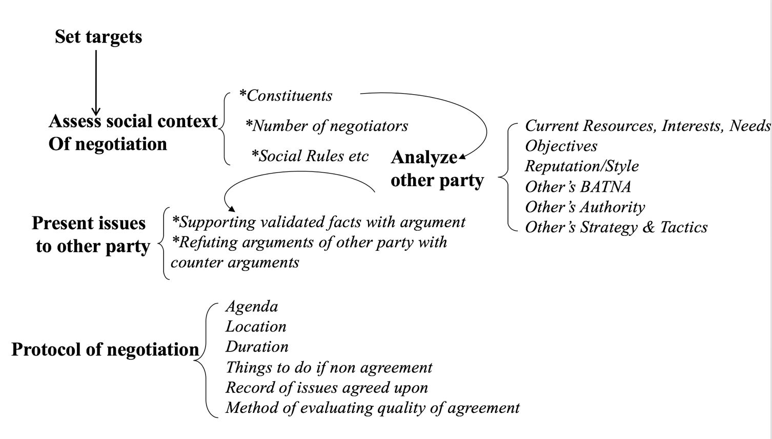
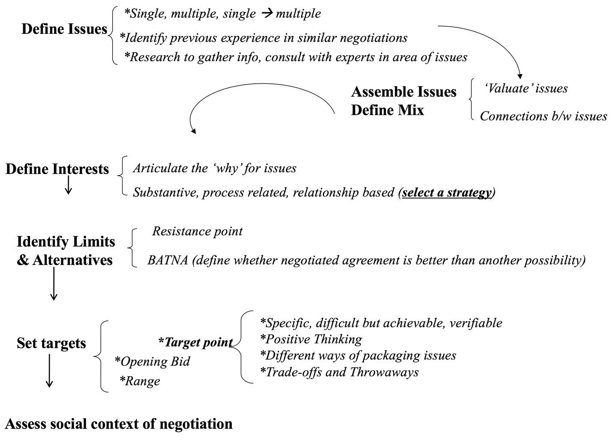
Figure 10.1 A mind map of prenegotiation

4.教学方法：讲授、讨论、比较、案例分析
5.教学评价：
（1）Define strategy and tactics.
（2）What specific steps are entailed in effective planning?

第十一章 Initiating Global Business Negotiations
1.教学目标：了解如何进行国际商务谈判开局
2.教学重难点：Making the First Offer；Opening High/Low
3.教学内容
一、Making the First Offer
（一）For fruitful negotiations, the opening offer should
- Stress mutual benefits
- Be clear and positive
- Imply flexibility
- Create interest
- Demonstrate confidence
- Promote goodwill
（二）Who should open first?
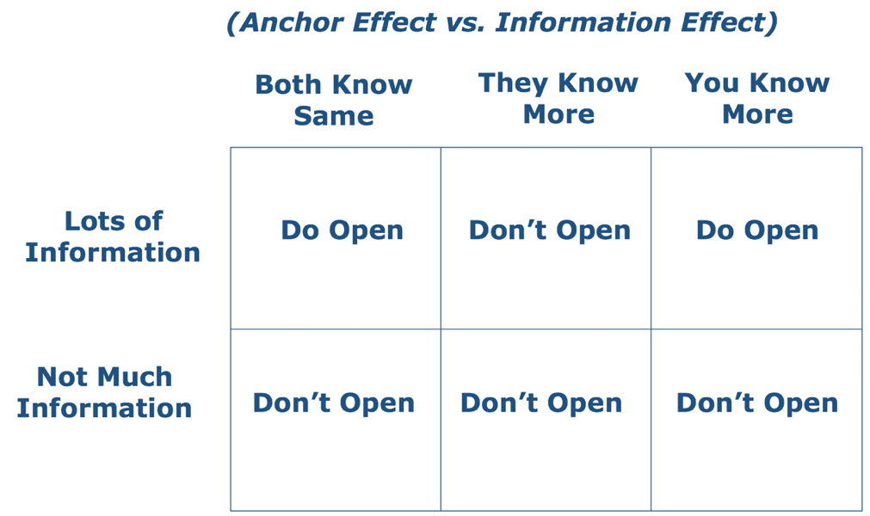
Figure 11.1 Balance between anchor effect and information effect

二、Opening High/Low
（一）Two tactics for offer
- Western Europe style: make an offer in a very high price, leaving a large space for you to negotiate, and the seller will give you some discount, trying to attract you to make a deal
- Japanese style: The seller will show you the lowest price in order to interest the buyer.
- Empirical work on the subject shows that negotiators who make extreme opening offer achieve higher settlement than those who make low or modest opening offers
（二）Why an initial high price
- Gathering and exchange information
- The other party must grant more concessions
- Allows the negotiator continue discussions
But
- Rejected by the other party
- Not conducive to a long-term relationship

三、Deceptive practices in quotes
• Yes or No? Why?
• Case Study
4.教学方法：讲授、讨论、比较、案例分析
5.教学评价：
What are the advantages and disadvantages of making a more extreme opening offer?

第十二章 Price Negotiations
1.教学目标：了解价格谈判中报价的因素、讨价还价的过程；掌握让步的基本原则和策略
2.教学重难点：Pricing Factors；The process of Price Negotiation ；Concession in price negotiation。
3.教学内容
一、Pricing Factors
- Pricing Objectives
- Cost Analysis
- Competition
- Customer Perspective
- Government and Pricing

二、Aspects of International Price Setting
- Pricing Orientation
- Export Pricing
- Escalation of Export Prices
- Export Price Quotation
三、The process of Price Negotiation
- Bidding(报价）
- Getting and making concessions
- Bargaining on price
- Breaking deadlocks
四、Concession in price negotiation
（一）What is concession?
A concession is a revision of a previous position you have held and justified publicly.
- Trading concessions are an essential element of the negotiation process.
- It is best to trade low-value concessions for higher-priority issues.
- The ultimate objective of trading concessions is to create a win-win situation, which opens the door to future business.
- Any concession making serves for the total profit-making in transaction
（二）Concession Patterns
- reciprocity: If a negotiator offers a concession, he/she expects the other party to yield similar ground
- Size: Initial stage—higher level concession
Closer to reservation point—smaller
- Pattern: How to trade concessions every step
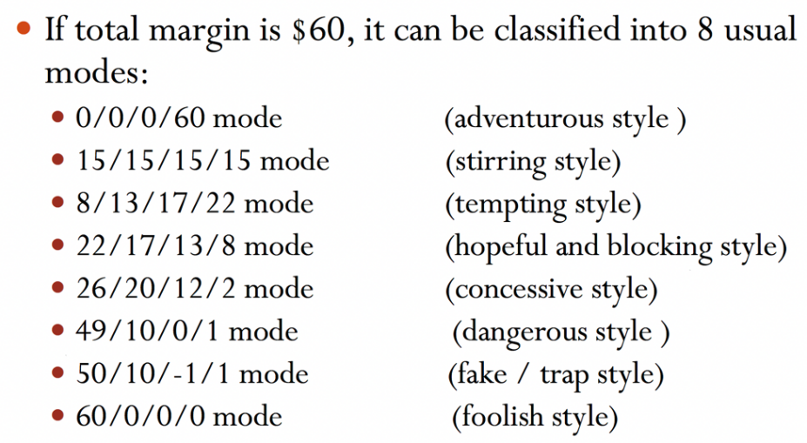
Case study:
4.教学方法：讲授、讨论、比较、案例分析
5.教学评价：
（1）What are the price concepts you have to consider in negotiation?
（2）Why is it advantageous to make an extreme opening offer?
（3）Discuss the importance of reciprocating (or not reciprocating) concessions.

第十三章 Closing Business Negotiation
1.教学目标：掌握商务谈判终结的方法和评价商务谈判成果的标准。
2.教学重难点：Methods of Closing Negotiations； Evaluate the social benefits of negotiation results
3.教学内容
- Methods of Closing Negotiations
- Alternative
- Assumption
- Concession
- Incremental
- Linkage
- Prompting
- Summarizing
- Splitting the Differences
- Trial
- Ultimatum/Or Else

- Time to Close
- Clues
- Deadline
- Final Points

- Evaluate the social benefits of negotiation results
- How to evaluate the interests of negotiation?
- Balance the social benefits and individual interests
- Case study
Figure 13.1 The circle of negotiation process
4.教学方法：讲授、讨论、比较、案例分析
5.教学评价：
（1）What does the choice of the appropriate closing negotiation method depend on?
（2）A few clues can help experienced negotiators detect when it is time to close the talks, would you illustrate some of them?

第十四章 Undertaking Renegotiation
1.教学目标：了解再谈判的原因，掌握再谈判的不同类型，以及如何进行再谈判。
2.教学重难点：Reasons for Renegotiation；Types of Renegotiation
3.教学内容
一、Reasons for Renegotiation
- Dimensions of International Business Environment
- Mechanisms for Settling Disputes
- Involvement of Government
- Cultural Differences Between Nations

二、Reducing the Need to Renegotiate
- Prevent Renegotiation
- Build in Renegotiation Costs

三、Types of Renegotiation
- Preemptive Negotiation
- Intradeal Renegotiation
- Postdeal Renegotiation
- Extradeal Renegotiation
- Restarting Negotiations After Reaching NO Agreement the First Time

四、Approaches to Renegotiation
- Clarify Ambiguities in the Existing Agreement
- Reinterpret Key Terms
- Waiver from One or More Requirement of the Agreement
- Rewrite the Agreement

五、Formal dispute-resolution methods
（一）Litigation
- Damage business relationship
- Heavy legal fess and time costs
- Difficult to reach the foreign assets
（二）Arbitration
- Use extensively as an alternative to litigation.
- Rely on coercion
- Bonding decision/ Hot tubbing
（三）Mediation
- A form of third-party intervention
- Help disputants come to an agreement
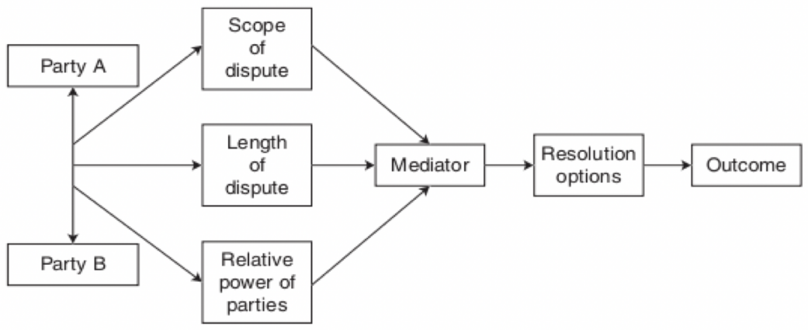
Figure 14.1 Using mediation to resolve international business disputes
Note: A mediator can help resolve acrimonious business disputes by deflating unreasonable claims and suggesting compromises.
4.教学方法：讲授、讨论、比较、案例分析
5.教学评价：
（1）What are the reasons for renegotiation?
（2）What are the five types of renegotiation?

第十五章 Managing Negotiation Impasses
1.教学目标：了解并掌握国际商务谈判僵局的起因，以及如何处理谈判中遇到的僵局。
2.教学重难点：What Causes Impasses and Intractable Negotiations? How to solve impasse
3.教学内容
一、The Nature of Impasse
Impasse is a condition or state of the conflict in which there is no apparent quick or easy resolution
- Impasse is not necessarily bad or destructive
- Impasse does not have to be permanent
- Impasse can be tactical or genuine
  - Tactical impasse: parties deliberately refuse to proceed as a way to gain leverage
  - Genuine impasse: parties feel unable to move forward without sacrificing something important
- Impasse perceptions can differ from reality
  - The perception of impasse can be created by an intransigent negotiator who is looking to extract concessions from the other party
  - Intransigence can be defined as a party’s unwillingness to move to any fallback position through concession or compromise

二、What Causes Impasses and Intractable Negotiations?
A negotiation becomes more tractable when it becomes easier to resolve, and intractable when it is more difficult to resolve
- Intractable conflicts vary along four dimensions
  - Divisiveness
  - Intensity
  - Pervasiveness
  - Complexity
三、How to solve impasse
（一）Impasses need to be resolved on three levels:
- Cognitive resolution
  - Change how the parties view the situation
- Emotional resolution
  - Change how the parties feel about the impasse
- Behavioral resolution
  - Specify ways the parties can stop difficult conflict dynamics
（二）Strategies for resolving impasses
- Reaching agreement on rules and procedures
- Reducing tension and synchronizing de-escalation of hostility
- Improving the accuracy of communication
- Controlling the number and size of issues
- Establishing common ground
- Enhancing the desirability of options and alternatives
四、Managing the Shadow Negotiation and Social Contract
（一）what are shadow negotiation and social contract
1. Shadow negotiation
occurs in parallel with the substantive negotiation and is concerned with how the negotiation will proceed
  - What ground the negotiation is going to cover
  - How the negotiators are going to work together
2.Social contract
The result of the shadow negotiation is a social contract regarding
  - How the negotiation will proceed
  - Who has influence and power
  - What the boundaries of the negotiation are
（二）Strategic levers to help navigate the shadow negotiation
1. Power moves: designed to bring bargainers back to the table
  - Three kinds of power moves
- Incentives – draw the attention to the importance of the negotiation
- Pressure tactics – lead the other party to realize that the status quo is unacceptable
- Enlistment of allies – help the other party see the advantage of negotiating
2. Process moves: designed to alter the negotiation process itself through adjustments to the agenda, sequencing, decision rules, and the like
3.Appreciative moves: designed to break cycles of contentiousness that may have led to deteriorating communication, acrimony, or even silence
4.教学方法：讲授、讨论、比较、案例分析
5.教学评价：
China and US trade negotiation

第十六章 Best Practices in Negotiations
1.教学目标：了解在国际商务谈判中需要做到的实践活动。
2.教学重难点：Ten Best Practices for Negotiators
3.教学内容
Ten Best Practices for Negotiators
1.Be prepared
— Understand and articulate your goals and interests
— Set high but achievable aspirations for negotiation
2. Diagnose the fundamental structure of the negotiation
— Make conscious decisions about the nature of the negotiation: is it a distributive or. integrative negotiation or blend of the two
— Choose strategies and tactics accordingly
3. Identify and work the BATNA
— Be vigilant about the BATNA
— Be aware of the other negotiator’s BATNA
4. Be willing to walk away
— Strong negotiators are willing to walk away when no agreement is better than a poor. agreement
— Have a clear walkaway point in mind where you will halt the negotiation
5.Master the key paradoxes of negotiation
— Claiming value versus creating value
— Sticking by your principles versus being resilient to the flow
— Sticking with the strategy versus opportunistic pursuit of new options
— Facing the dilemma of honesty: honest and open versus closed and opaque
— Facing the dilemma of trust: trust versus distrust
6. Remember the intangibles
— “See what is not there”
— Ask questions
— Take an observer or listener with you to the
negotiation
7. Actively manage coalitions
— Coalitions against you
— Coalitions that support you
— Undefined coalitions that may materialize for or against you
8. Savor and protect your reputation
— Start negotiation with a positive reputation
— Shape your reputation by acting in a consistent and fair manner
9. Remember that rationality and fairness are relative
— Question your perceptions of fairness and ground them in clear principles
— Find external benchmarks of fair outcomes
— Engage in dialogue to reach consensus on fairness
10. Continue to learn from your experience
— Practice the art and science of negotiation
— Analyze each negotiation
      - Plan a personal reflection time after each negotiation
      - Periodically take a lesson from a trainer or a coach
      - Keep a personal diary on strengths and weaknesses and develop a plan to work on weaknesses
4.教学方法：讲授、讨论、比较、案例分析
5.教学评价
- Negotiation in the context of digital economy

第十七章 Business negotiation simulation
1.教学目标：模拟商务谈判，掌握商务谈判的一般过程和技巧
2.教学重难点：通过模拟商务谈判，掌握商务谈判的一般过程和技巧
3.教学内容：Case: Cross-Border Merger and Acquisition negotiation
4.教学方法：讲授、讨论、比较、案例分析
5.教学评价
Business negotiation simulation
四、学时分配（四号黑体）
表2：各章节的具体内容和学时分配表（五号宋体）
章节 | 章节内容 | 学时分配
第一章 | International Business Negotiation: An Overview(1) | 3
第二章 | International Business Negotiation: An Overview(2) | 3
第三章 | Perception, Cognition and Emotion | 3
第四章 | Communication Skills for Effective Negotiation | 3
第五章 | International and Cross-Cultural Negotiation(1) | 3
第六章 | International and Cross-Cultural Negotiation(2) | 3
第七章 | Effective Conflict Management | 3
第八章 | Distributive Bargaining and Integrative Negotiation | 3
第九章 | Prenegotiation Planning(1) | 3
第十章 | Prenegotiation Planning(2) | 3
第十一章 | Initiating Global Business Negotiations | 3
第十二章 | Price Negotiations | 3
第十三章 | Closing Business Negotiation | 3
第十四章 | Undertaking Renegotiation | 3
第十五章 | Managing Negotiation Impasses | 3
第十六章 | Best Practices in Negotiations | 3
第十七章 | Business negotiation simulation | 3
五、教学进度（四号黑体）
表3：教学进度表（五号宋体）
周次 | 日期 | 章节名称 | 内容提要 | 授课时数 | 作业及要求 | 备注
1-2 |  | International Business Negotiation: An Overview | 国际商务谈判基本概念 | 6 | 了解国际商务谈判的基本概念；熟悉特征与职能
3 |  | Perception, Cognition and Emotion | 商务谈判中的认知与情绪 | 3 | 了解国际商务谈判中的认知偏差，情绪控制
4 |  | Communication Skills for Effective Negotiation | 商务沟通中语言沟通、行为语言沟通以及文字处理 | 3 | 掌握语言沟通和行为沟通基本技巧和方法，加强文字处理
5-6 |  | International and Cross-Cultural Negotiation | 跨文化商务谈判的复杂因素 | 6 | 掌握跨文化商务谈判复杂性的成困
7 |  | Effective Conflict Management | 有效冲突管理 | 3 | 掌握冲突的概念以及如何有效进行冲突管理
8 |  | Distributive Bargaining and Integrative Negotiation | 商务谈判的两种不同类型 | 3 | 掌握商务谈判的两种不同类型，以及在谈判中应如何选择
9-10 |  | Prenegotiation Planning | 国际商务谈判的准备 | 6 | 掌握商务谈判的准备工作，并撰写完整的商务谈判计划书
11 |  | Initiating Global Business Negotiations | 国际商务谈判的开启 | 3 | 掌握如何开启一个国际商务谈判
12 |  | Price Negotiations | 价格谈判 | 3 | 掌握国际商务谈判中价格的影响因素，讨论还价的过程和让步的原则
13 |  | Closing Business Negotiation | 结束国际商务谈判 | 3 | 掌握判断商务谈判结束的条件
14 |  | Undertaking Renegotiation | 再谈判 | 3 | 掌握再谈判的原因、类型和方法
15 |  | Managing Negotiation Impasses | 商务谈判僵局 | 3 | 掌握如何解决商务谈判僵局
16 |  | Best Practices in Negotiations | 国际商务谈判应注意事项 | 3 | 掌握国际商务谈判的注意事项
17 |  | Business negotiation simulation | 模拟商务谈判 | 3 | 模拟商务谈判
六、教材及参考书目
教材: Roy J. Lewicki, Bruce Barry, David M. Saunders. Business Negotiation(8th edition)[M]. CHINA RENMIN UNIVERSITY PRESS, 2020.
参考书目：[1]Claude Selich, Subihash C. Jayin, International Business Negotiations (English Edition), People's University of China Press, 2013.
[2]Reynolds, Valentine & Munter. Guide to Cross-Cultural Communications[M]， Prentice Hall，2011.
[3]Budjac Corvette. Conflict Management: A Practical Guide to Developing Negotiation Strategies[M], Prentice Hall,2007.
[4]李晶.商务谈判[M].苏州大学出版社，2019.
七、教学方法
1．讲授法：理论讲授，主要教学方法，贯穿教学全过程。
2．讨论法：对本门课程的主要内容，采用问题形式，在师生和学生之间展开讨论。
3. 比较法：通过比较不同研究方式、研究方法等，深化学生对相关知识点的认识。
4. 举例法：通过举例，强化学生对相关知识点的认识。
5. 案例分析法：通过案例解读、案例问题回答，提高学生理论知识运用能力。
八、考核方式及评定方法（四号黑体）
（一）课程考核与课程目标的对应关系 （小四号黑体）
表4：课程考核与课程目标的对应关系表（五号宋体）
课程目标 | 考核要点 | 考核方式
课程目标1 | 国际商务谈判的基本原理、特征、相关理论基础 | 1.课堂交流  2.课后作业  3.期末考试
课程目标2 | 国际商务谈判的过程、策略和技巧 | 1.课堂交流  2.课后作业  3.期末考试
课程目标3 | 有效、系统地计划和准备一个商务谈判，包括撰写商务谈判计划书。 | 1.课堂交流  2.课后作业  3.期末考试
（二）评定方法
1．评定方法
平时成绩：20%，文案作业及模拟谈判：30%，期末考试50%。
2．课程目标的考核占比与达成度分析
表5：课程目标的考核占比与达成度分析表
考核占比  课程目标 | 平时 | 期中 | 期末 | 总评达成度
课程目标1 | 30 | 30 | 40 | （例：课程目标1达成度={0.3ｘ平时目标1成绩+0.2ｘ期中目标1成绩+0.5ｘ期末目标1成绩}/目标1总分。按课程考核实际情况描述）
课程目标2 | 30 | 30 | 40
课程目标3 | 20 | 20 | 60
（三）评分标准
课程  目标 | 评分标准
课程  目标 | 90-100 | 80-89 | 70-79 | 60-69 | ＜60
课程  目标 | 优 | 良 | 中 | 合格 | 不合格
课程  目标 | A | B | C | D | F
课程  目标1 | 非常全面、准确地理解国际商务谈判基本概念、原理、特征及相关理论 | 比较全面、准确地理解国际商务谈判基本概念、原理、特征及相关理论 | 对国际商务谈判基本概念、原理、特征及相关理论理解较为准确，但不全面 | 基本正确理解国际商务谈判的基本概念、原理、特征及相关理论 | 不能正确理解国际商务谈判的基本概念、原理、特征及相关理论
课程  目标2 | 非常全面、准确地理解国际商务谈判的过程，能够熟练运用策略和技巧 | 比较全面、准确地理解国际商务谈判的过程，较为熟练运用国际商务谈判的策略和技巧 | 对国际商务谈判的过程、国际商务谈判策略和技巧的理解较为准确，但不全面 | 基本正确理解国际商务谈判的过程，以及国际商务谈判策略和技巧 | 不能正确理解国际商务谈判的过程，以及国际商务谈判的策略和技巧
课程  目标3 | 非常全面、准确地掌握如何有效、系统地计划和准备一个商务谈判，包括撰写商务谈判计划书 | 比较全面、准确地掌握如何有效、系统地计划和准备一个商务谈判，包括撰写商务谈判计划书 | 对如何有效、系统地计划和准备一个商务谈判，包括撰写商务谈判计划书的理解较为准确，但不够全面 | 基本正确掌握如何有效、系统地计划和准备一个商务谈判，包括撰写商务谈判计划书 | 不能正确掌握如何有效、系统地计划和准备一个商务谈判，包括撰写商务谈判计划书

